DEFENCE QUESTIONS
Question No- 03
High-Concurrency Processing for 800 Applicants

Raised Problem:
“If 800 students apply for a single placement drive within 15 minutes, what is your backend architecture to process, parse, and rank them without hitting LLM API rate limits?”

The Scalability Reality:
Synchronous LLM Calls Will Collapse In real placement drives, 800+ students may apply within a 15-minute window. Calling commercial LLM APIs (OpenAI / Gemini) synchronously during this spike can trigger HTTP 429 rate limits, cascading timeouts and unsustainable API bills. An enterprise architecture should not rely on raw LLM calls in the critical request path. The proposed approach uses a queue (Redis / BullMQ), asynchronous background workers, structured extraction and deterministic matching.

Problem / Loopholes Identified
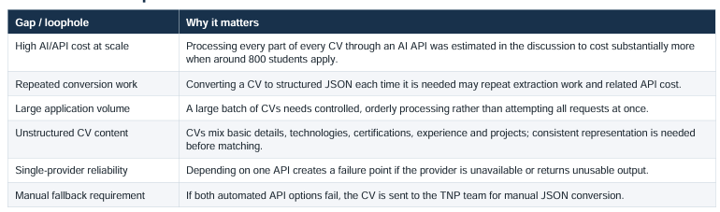

Goal of the Solution
Reduce avoidable AI processing cost while keeping CV processing orderly and producing a consistent JSON representation for matching against company JDs. The design uses Python libraries for selected CV sections, AI APIs for more interpretive sections, provider fallback and a FIFO queue to manage work.
Core design principle: extract deterministically where possible; use AI only where interpretation is needed; queue work and preserve a manual fallback.

Proposed Solution & Extraction Strategy
The key cost-optimization decision is to avoid sending the entire CV through AI. Extract selected sections with Python libraries and reserve AI processing for sections that need interpretation.
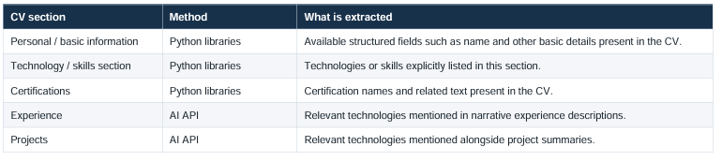
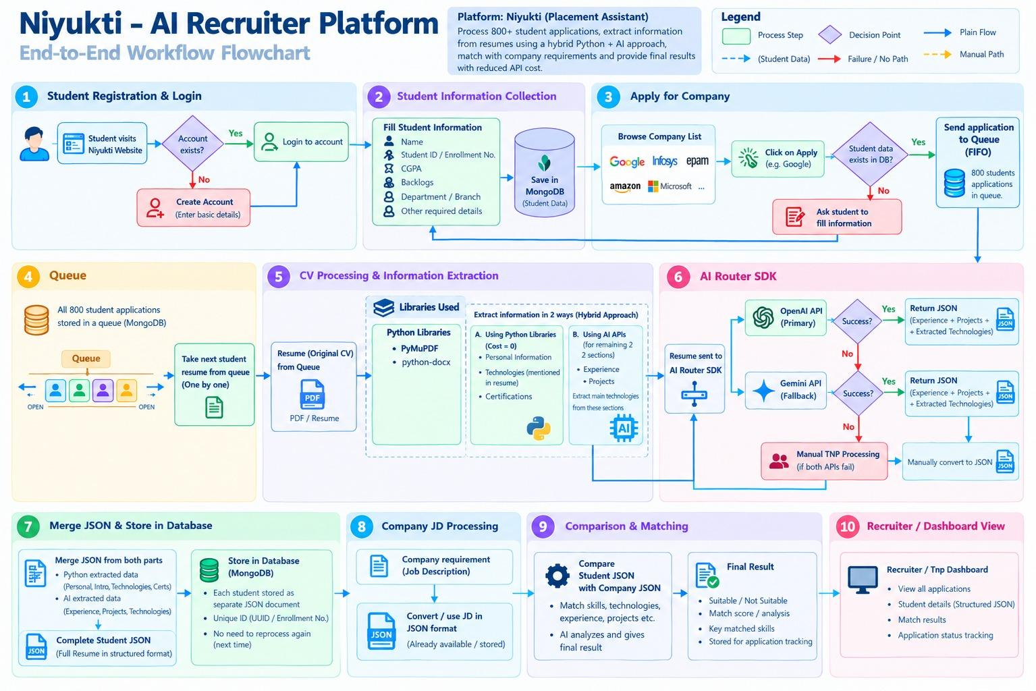

AI API Routing & Failure Handling
- Primary route: Send the CV to the OpenAI API for extraction of the Experience and Projects sections.
- Fallback route: If the primary API is unavailable or fails, use the Gemini API for the same extraction.
- Manual route: If both automated options fail, route the CV to the TNP team for manual conversion into the required JSON structure.
- Routing layer: The AI Router SDK is described as the layer that allows use of OpenAI and Gemini APIs. The exact retry policy and failure thresholds were not specified in the discussion.

Queue, JSON & Persistence
- CVs enter a FIFO (First In, First Out) queue, so the earliest queued CV is processed first.
- A worker takes CVs from the queue one by one and sends the original CV to the extraction route; it does not need to pre-convert every CV to JSON before routing.
- Python-extracted and AI-extracted fields are combined into one structured student-CV JSON object.
- MongoDB stores student information and processed JSON. A separate second MongoDB/SQL database was discussed as a possibility and then explicitly dropped; it is not part of the final design.
- The company JD is available as structured JSON. Student JSON is compared with company JD JSON to produce an eligibility/match result.

Expected Benefit & Cost Estimate
The stated design goal is to reduce API usage by applying AI only to Experience and Projects, while Python libraries handle Personal/Basic Information, Technology and Certifications.
The discussion mentioned illustrative estimates of approximately 57,000 for processing the whole CV with AI versus approximately 1,500 in a worst-case scenario for the two AI-processed sections.
These are discussion estimates, not independently validated forecasts; actual cost depends on volume, CV length, provider/model pricing and retry rate.

